

IRF21/7

Gateway determination report – PP_2021_WINGE_001_00
Burgess Street Reclassification, 7-11 Burgess Street, Bundanoon (0 homes and 0 jobs)
January 21

Published by NSW Department of Planning, Industry and Environment
dpie.nsw.gov.au
Title: Gateway determination report – PP_2021_WINGE_001_00
Subtitle: Burgess Street Reclassification, 7-11 Burgess Street, Bundanoon (0 homes and 0 jobs)
© State of New South Wales through Department of Planning, Industry and Environment 2021. You may copy, distribute, display, download and otherwise freely deal with this publication for any purpose, provided that you attribute the Department of Planning, Industry and Environment as the owner. However, you must obtain permission if you wish to charge others for access to the publication (other than at cost); include the publication in advertising or a product for sale; modify the publication; or republish the publication on a website. You may freely link to the publication on a departmental website.
Disclaimer: The information contained in this publication is based on knowledge and understanding at the time of writing (January 21) and may not be accurate, current or complete. The State of New South Wales (including the NSW Department of Planning, Industry and Environment), the author and the publisher take no responsibility, and will accept no liability, for the accuracy, currency, reliability or correctness of any information included in the document (including material provided by third parties). Readers should make their own inquiries and rely on their own advice when making decisions related to material contained in this publication.

Contents
1 Planning Proposal 2
1.1 Overview and objectives of planning proposal 2
1.2 Explanation of provisions 2
1.3 Site description and surrounding area 3
1.4 Mapping 3
2 Need for the planning proposal 3
3 Strategic assessment 4
3.1 Regional Plan 4
3.2 Local 4
3.3 Section 9.1 Ministerial Directions 5
3.4 State environmental planning policies (SEPPs) 5
4 Site-specific assessment 5
4.1 Environmental 5
4.2 Social and economic 5
4.3 Infrastructure 6
5 Consultation 6
5.1 Community 6
5.2 Agencies 6
6 Timeframe 6
7 Local plan-making authority 6
8 Assessment Summary 6
9 Recommendation 7

Table 1 Reports and plans supporting the proposal
Relevant reports and plans
Planning Proposal (dated January 2021)
Certificate of Title
Deposited Plan – DP 1246504
Council Meeting Minutes – 12 April 2017
Council Meeting Agenda – 12 April 2017
Council Meeting Minutes – 6 June 2020
Council Meeting Agenda – 6 June 2020

Planning Proposal

Overview and objectives of planning proposal
Table 2 Planning proposal details
LGA | LGA name
PPA | Wingecarribee Shire Council
NAME | Burgess Street Reclassification (0 homes and 0 jobs)
NUMBER | PP_2021_WINGE_001_00
LEP TO BE AMENDED | Wingecarribee Local Environmental Plan 2010
ADDRESS | 7-11 Burgess Street, Bundanoon
DESCRIPTION | Lot 1 DP 1246504
RECEIVED | 4/01/2021
FILE NO. | IRF21/7
POLITICAL DONATIONS | There are no donations or gifts to disclose and a political donation disclosure is not required
LOBBYIST CODE OF CONDUCT | There have been no meetings or communications with registered lobbyists with respect to this proposal
The planning proposal contains objectives and intended outcomes that adequately explain the intent of the proposal.
The objectives of the planning proposal are to:
- Reclassify the subject land from Community to Operational so it can be consolidated with adjoining Operational land for use by local not-for-profit community groups (Bundanoon Community Association, Bundanoon Men’s Shed and Bundanoon Highlands Gathering).
The objectives of this planning proposal are clear and adequate.

Explanation of provisions
The planning proposal seeks to amend the Wingecarribee LEP 2010 per the changes below:
Table 2 Current and Proposed controls
Control | Current | Proposed
Reclassify land from Community to Operational | Community | Operational
Council is not seeking to discharge any interests from the subject land, and it is not a Public Reserve.
The planning proposal contains an explanation of provisions that adequately explains how the objectives of the proposal will be achieved.

Site description and surrounding area
The subject land is located at 7-11 Burgess Street Bundanoon in the Wingecarribee local government area (Figure 1). The land is a former road reserve, is rectangular in shape and has an area of 406.4 m².
The land is zoned R3 Medium Density Residential with a minimum lot size of 700 m².
The subject land is a former public road which was closed in 2018 so that the land could be utilised by the current community group users of the adjoining Council owned property.
The land adjoins buildings and land used by local non-for-profit community groups (Bundanoon Community Association, Bundanoon Men’s Shed and Bundanoon Highlands Gathering). The Bundanoon Rural Fire Service and Preschool are also located further to the west off Burgess Street. Some vacant land also adjoins the northern portion of the site.
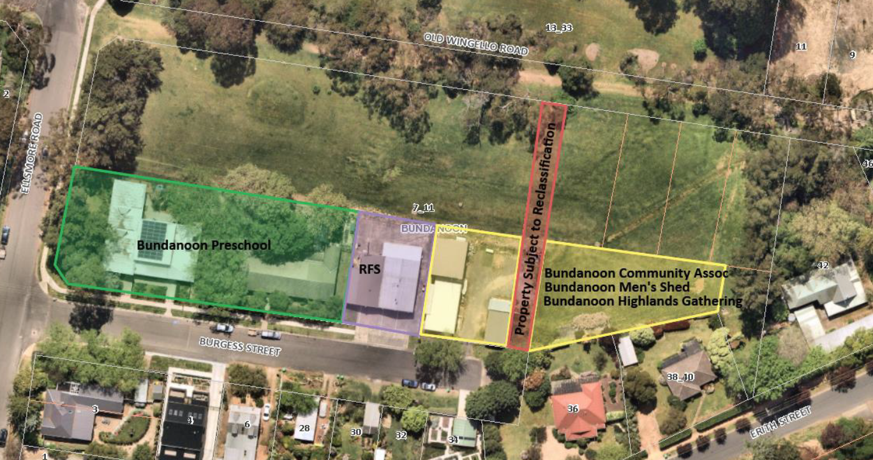
Figure 1 Subject site (Source: Planning Proposal)

Mapping
A new Reclassification Map will be required to be created as a result of the proposal.
The planning proposal does not include a reclassification map. As such, a condition is recommended requiring Council to prepare and exhibit draft maps with the planning proposal.

Need for the planning proposal
The planning proposal is needed to enable three local not-for-profit community organisations a greater licensed/lease area affording them the opportunity to expand their operations on site as needed.
Council considers this benefit will flow on to the local community who will be party to the community groups expanded services and support networks currently on offer.
Community land is land council makes available for use by the general public such as parks, reserves or sports grounds. The land is a former road reserve which is currently used for parking and vehicular movements by the adjoining community groups.
Community land can only be leased if an adopted Plan of Management (PoM) is in place. There is no adopted PoM in place for the subject land.
Operational land is land which facilitates the functions of Council. Given the intended use of the site, and that it lies between other areas of Council-owned Operational land (being those leased to local community groups), Council considers reclassification of the subject land to Operational land to be appropriate.
Council has also advised classification of public land generally occurs when it is first acquired by a council and classified as either community or operational. However, Council failed to resolve to classify the land Operational when it was acquired and consequently it was automatically classified Community Land in accordance with section 31 of the Local Government Act 1993. Reclassification of the land must now occur to Operational to reflect its actual and intended uses.
The Department concurs the site would be more appropriately classified as Operational Land given the site context and current uses. Council has confirmed the land is not used as public open space and there is no intention for Council to dispose of or sell the land. The Department concludes there is public benefit in reclassifying the land to enable a larger operating area for local community groups.
A planning proposal of this nature is considered the best means of achieving the objectives and intended outcomes.

Strategic assessment

Regional Plan
The following table provides an assessment of the planning proposal against key relevant aspects of the South East and Tablelands Regional Plan.
Table 3 Regional Plan assessment
Regional Plan Objectives | Justification
Direction 22 | The proposal would contribute to building socially inclusive, safe and healthy communities by enabling the enlargement of local community group operating areas.
It is noted Section B (Part 3) of the planning proposal references the incorrect site when addressing consistency with the Regional Plan. It is recommended this be updated prior to public exhibition.

Local
The proposal states that it is consistent with the following local plans and endorsed strategies. It is also consistent with the strategic direction and objectives, as stated in the table below:

Table 4 Local strategic planning assessment
Local Strategies | Justification
Wingecarribee Local Strategic Planning Statement | The planning proposal is consistent with key planning priorities identified in the LSPS that rely on community facilities to enhance residential amenity and housing choice (e.g. Planning Priority 6.3).
Wingecarribee Community Strategic Plan | The planning proposal is consistent with goals and strategies contained within the CSP relating to:  - making well informed decisions and effectively managing assets (1.1 and 1.1.2);  - living happy and healthy lifestyles (2.1) and availability of local health services (2.1.1);  - planning and delivery of local services to the community (2.1.5, 2.3 and 2.3.1); and  - creating a vibrant community and inviting public spaces (3.3).

Section 9.1 Ministerial Directions
The planning proposal’s consistency with relevant section 9.1 Directions is discussed below:
Table 5 Section 9.1 Ministerial Direction assessment
Directions | Consistent/ Not Applicable | Reasons for Consistency or Inconsistency
Direction 4.4 – Planning for Bushfire Protection | Not Applicable | The land is not mapped as bushfire prone land.
Direction 5.2 – Sydney Drinking Water Catchment | Yes | No development would occur as a result of the proposal. As such, no negative water impacts are anticipated.

State environmental planning policies (SEPPs)
The planning proposal is not inconsistent with relevant SEPPs.

Site-specific assessment

Environmental
The site is not mapped as containing threatened ecological communities and not adverse environmental impacts are anticipated as a result of the proposal.

Social and economic
The proposal would result in positive social impacts by enabling the enlargement of local community group operating areas.
No negative economic impacts are anticipated as a result of the proposal.

Infrastructure
No additional public infrastructure requirements or infrastructure impacts would result from the proposal.

Consultation

Community
Council proposes a community consultation period of 28 days.
The exhibition period proposed is considered appropriate, and forms to the conditions of the Gateway determination.

Agencies
Council proposes to consult with agencies as required under the Gateway determination.
It is recommended the following agencies be consulted on the planning proposal:
- Water NSW; and
- NSW Rural Fire Service.

Timeframe
Council proposes an 8 month time frame to complete the LEP.
The Department recommends a time frame of 9 months to ensure it is completed promptly in line with its commitment to reduce processing times.
A condition to the above effect is recommended in the Gateway determination.

Local plan-making authority
Council has not requested to be the Local Plan-Making authority given it proposes reclassification of land.
However, as the planning proposal does not seek to discharge any interests or impact a public reserve, the Department recommends that Council be authorised to be the local plan-making authority for this proposal.

Assessment Summary
The planning proposal is supported to proceed with conditions for the following reasons:
- it would result in a land classification which more appropriately reflects the adjoining, current and intended uses;
- it would not result in the loss of public open space; and
- it would enable the enlargement of local community group operating areas to benefit to the local community.
As discussed in the previous sections 4 and 5, the proposal should be updated prior to public exhibition to include:
- draft Reclassification Maps; and
- a site-specific assessment addressing consistency with the South East and Tablelands Regional Plan.

Recommendation
It is recommended the delegate of the Secretary agree that the planning proposal is consistent with all relevant section 9.1 Directions.
It is recommended the delegate of the Minister determine that the planning proposal should proceed subject to the following conditions:
- The planning proposal is to be updated prior to public exhibition to include:
- draft Reclassification Maps; and
- a site-specific assessment addressing consistency with the South East and Tablelands Regional Plan.
- Consultation is required with the following public authorities:
- Water NSW; and
- NSW Rural Fire Service.
- The planning proposal should be made available for community consultation for a minimum of 28 days.
- The timeframe for completing the LEP is to be 9 months from the date of the Gateway determination.
- Given the nature of the proposal, Council should be authorised to be the local plan-making authority.
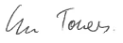 25/1/21
Graham Towers
Manager, Southern Region
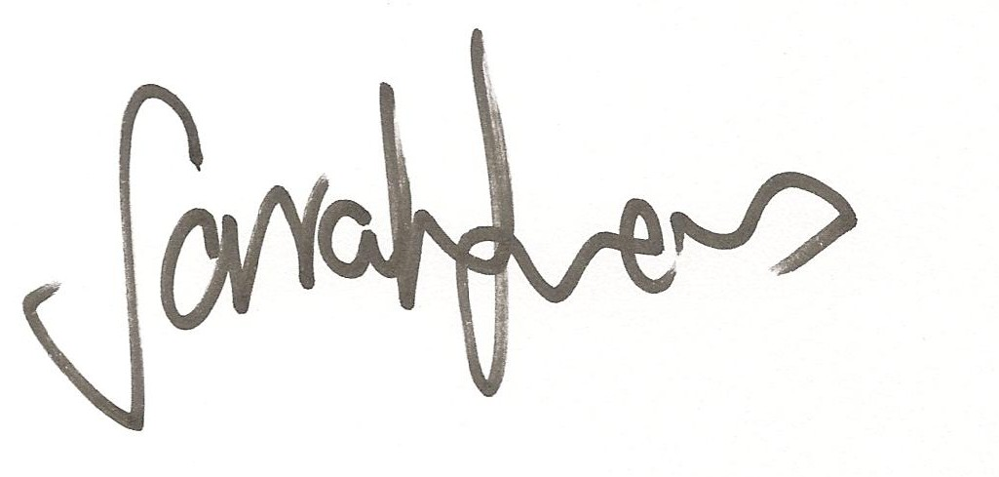27/01/2021
Sarah Lees
Director, Southern Region

Assessment officer
Andrew Hartcher
Specialist Planner, Southern Region
4247 1823

Attachment A – Planning Proposal
Attachment B – Gateway determination
Attachment C – Letter to Council

